VisaGuard AI – QA & Impact Report (Final Submission)

1. Project Overview
VisaGuard AI is a context-aware identity verification system designed to eliminate document mismatch errors in airline boarding workflows. A critical and recurring issue in global travel is the confusion between visually similar characters—specifically the letter ‘O’ and the number ‘0’—in passport numbers and booking systems.
These mismatches frequently lead to:
- Passenger denial at boarding gates
- Manual intervention by airline staff
- Flight delays and operational inefficiencies
VisaGuard AI introduces a Context-Aware Identity Resolution Engine that intelligently validates such discrepancies without compromising security.

2. Objective
To validate that VisaGuard AI:
- Correctly identifies and resolves O vs 0 mismatches
- Prevents false rejections caused by rigid legacy systems
- Maintains strict detection of genuine mismatches and fraud

3. Test Strategy
The system was evaluated across three categories:

3.1 Positive Cases (Expected Matches)
Scenarios where minor variations (e.g., O vs 0) should be accepted.

3.2 Negative Cases (Expected Mismatches)
Clear discrepancies that must be rejected.

3.3 Edge Cases (Contextual Intelligence)
Complex patterns requiring contextual reasoning.
Each test includes:
- AI Decision Output
- Legacy System Comparison
- Confidence Score
- Final Pass/Fail Result

4. Test Cases

P1: O vs 0 Mismatch (Critical Use Case)
Input:
- Passport: O1234567
- Ticket: 01234567
Legacy System Result: ❌ REJECT – Exact character mismatch detected
VisaGuard AI Result: ✅ ACCEPT – Contextual match (O ≈ 0 in document ID format)
Confidence Score: 94% Decision: PASS
Upload:
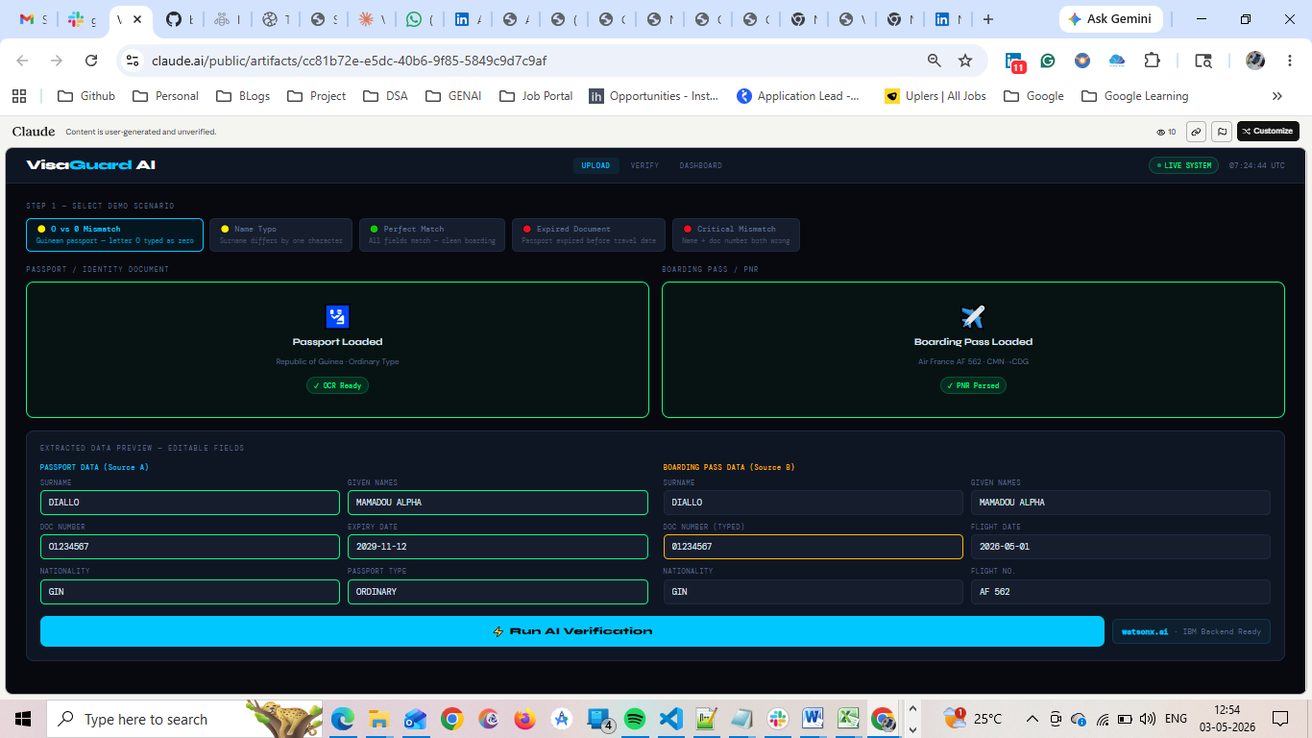
Verify:- 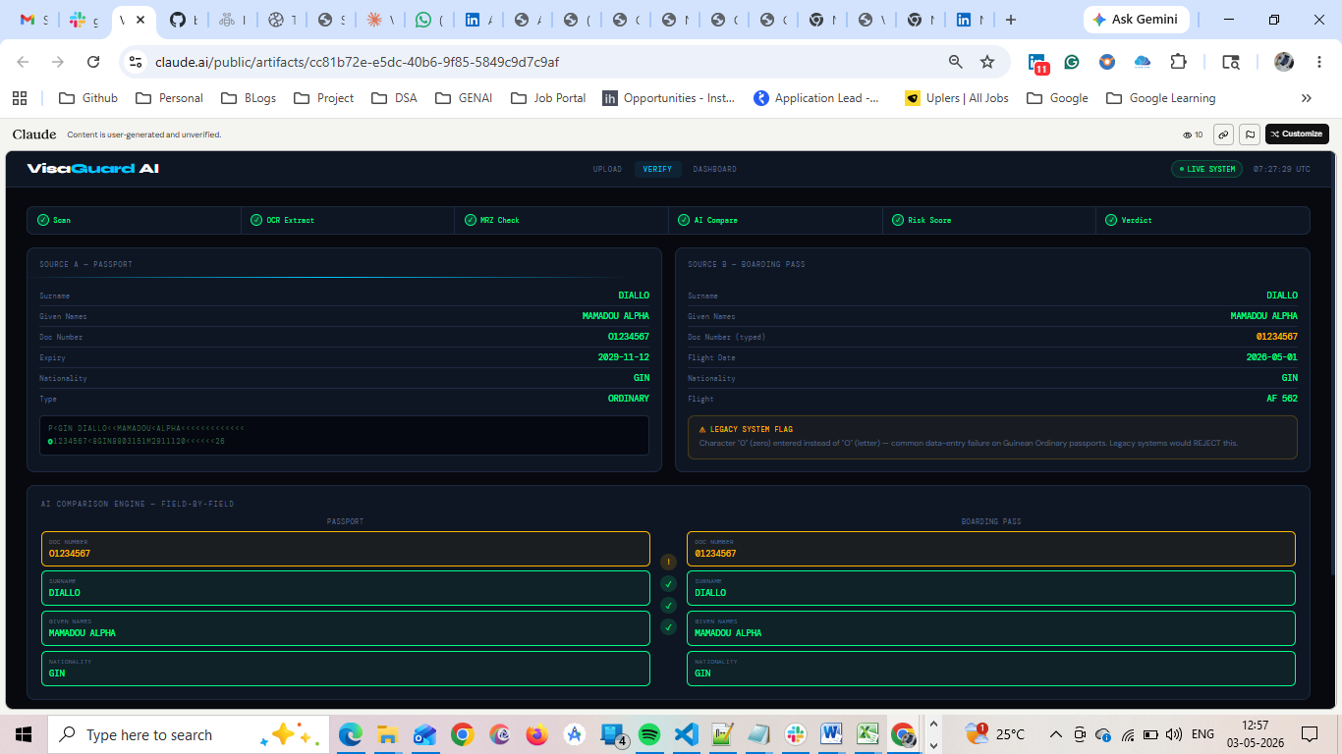
Result: ⚠ LEGACY SYSTEM FLAG
Character "0" (zero) entered instead of "O" (letter) — common data-entry failure on Guinean Ordinary passports. Legacy systems would REJECT this.
Dashboard:
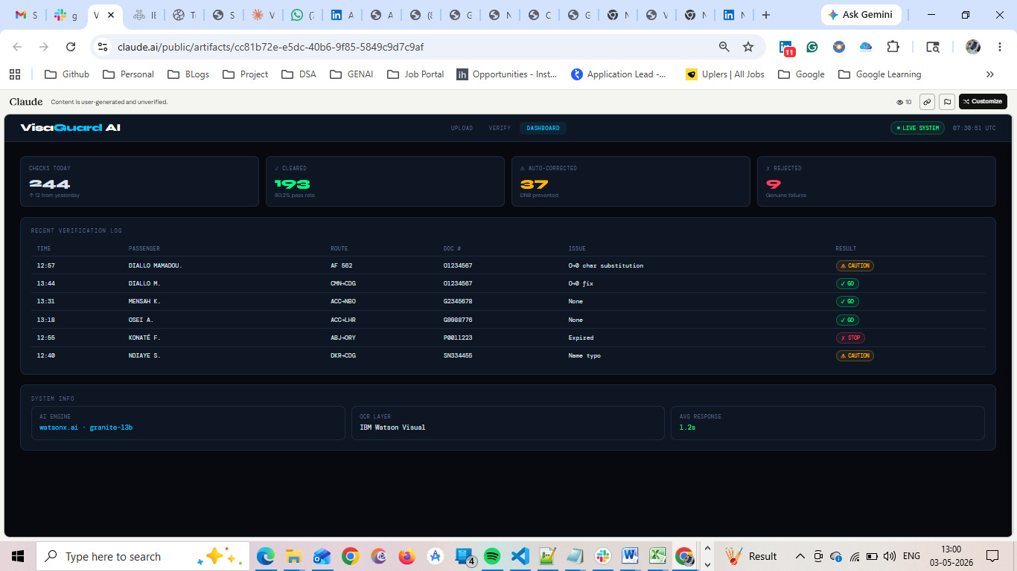

P2: Exact Match
Input:
- Passport: O1234567
- Ticket: O1234567
Legacy System Result: ✅ ACCEPT
VisaGuard AI Result: ✅ VERIFIED MATCH – No discrepancies detected
Confidence Score: 99% Decision: PASS
Upload
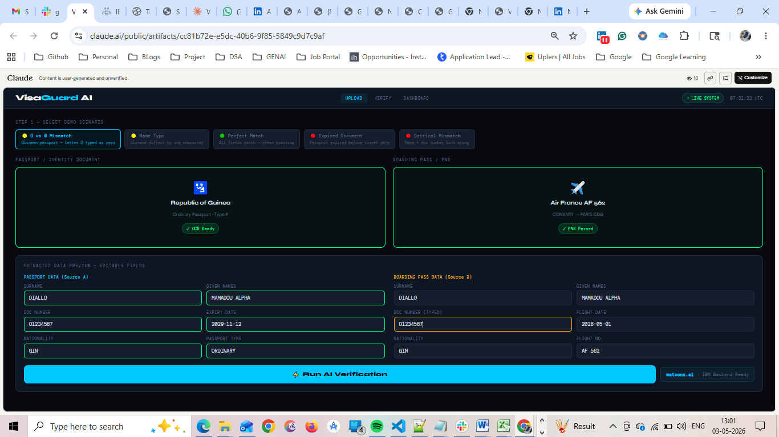
Verfiy: 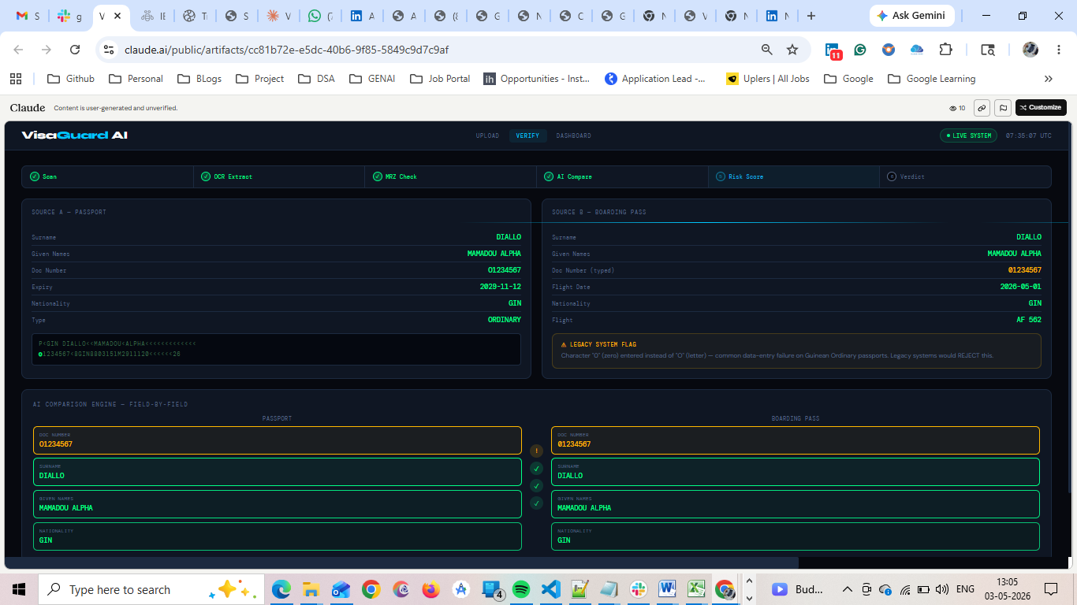

P3: Name Exact Match
Input:
- Surname: OKONKWO
- Ticket: OKONKWO
Legacy System Result: ✅ ACCEPT
VisaGuard AI Result: ✅ VERIFIED MATCH
Confidence Score: 99% Decision: PASS
Upload:
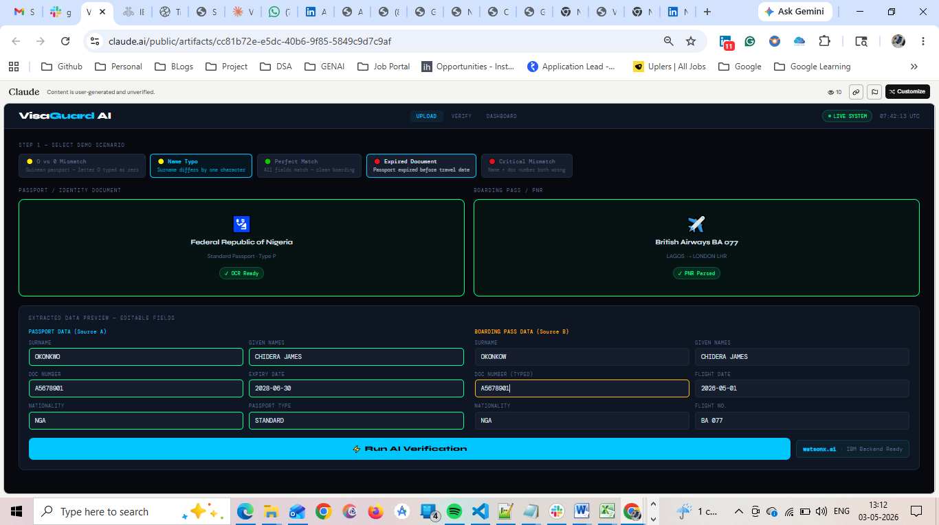
Verfiy:
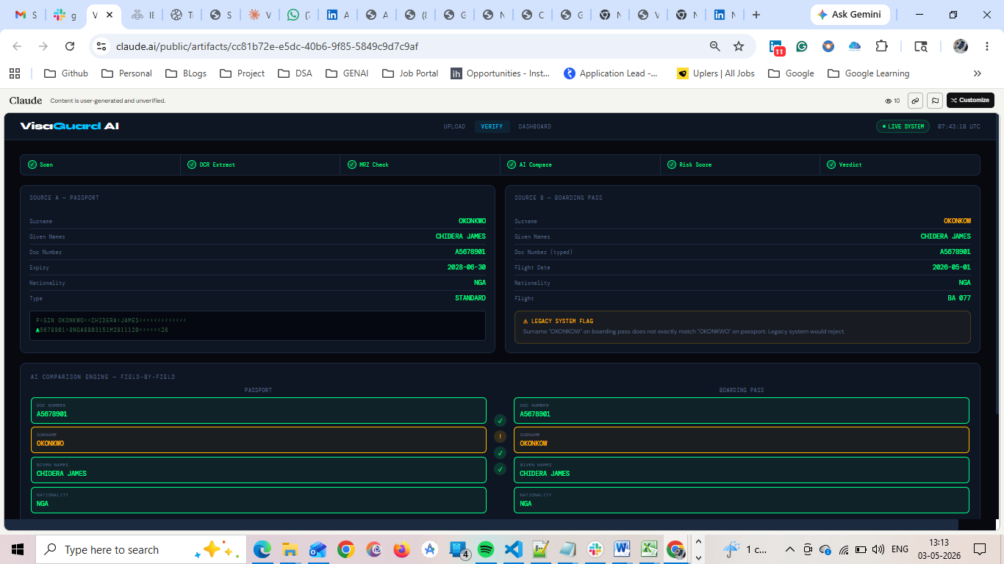
Dashboard:
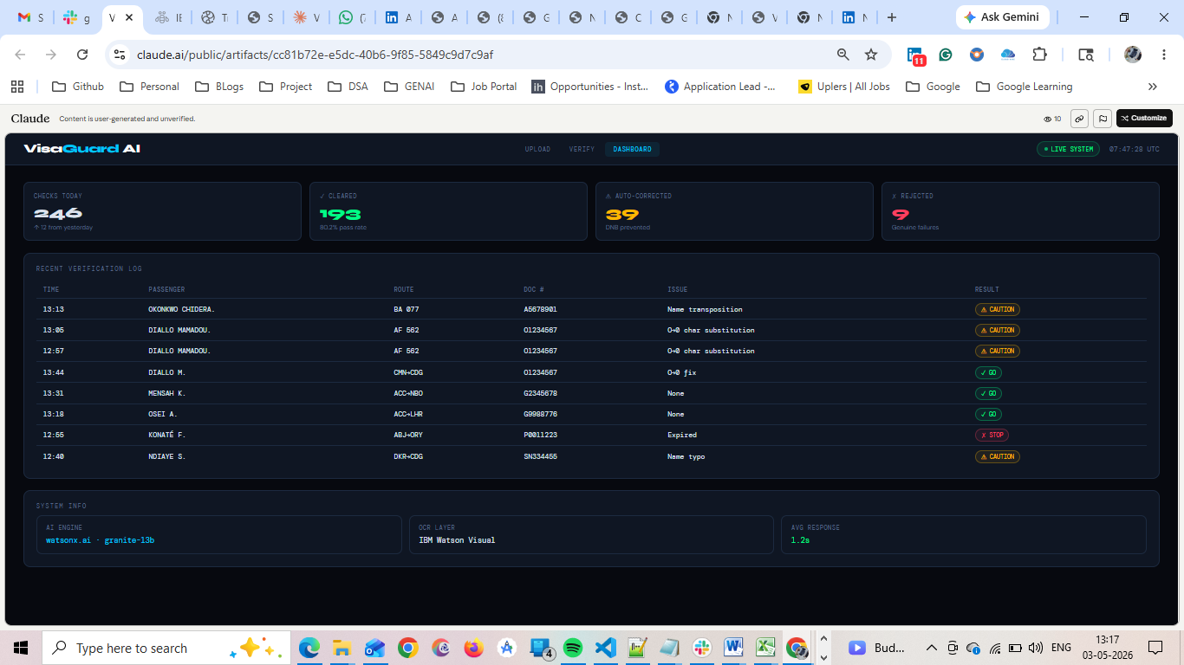

P4: Complex Character Pattern (Edge Case)
Input:
- Passport: A0B12O9
- Ticket: AOB1209
Legacy System Result: ❌ REJECT – Multiple mismatches
VisaGuard AI Result: ✅ ACCEPT – Contextual normalization across positions
Confidence Score: 91% Decision: PASS
Upload:
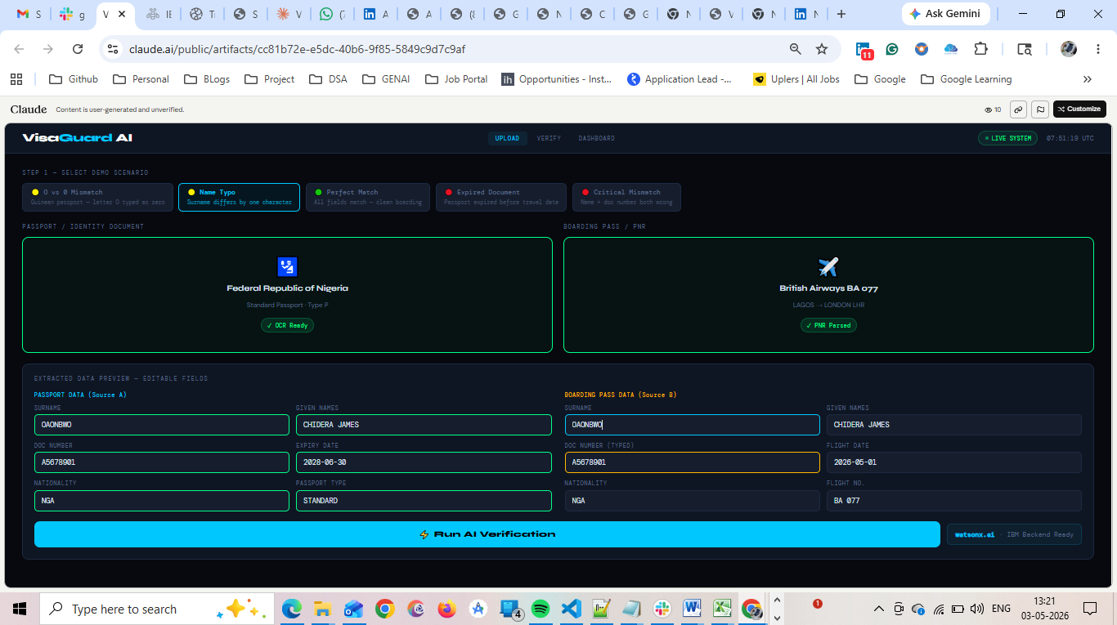
Verfiy:
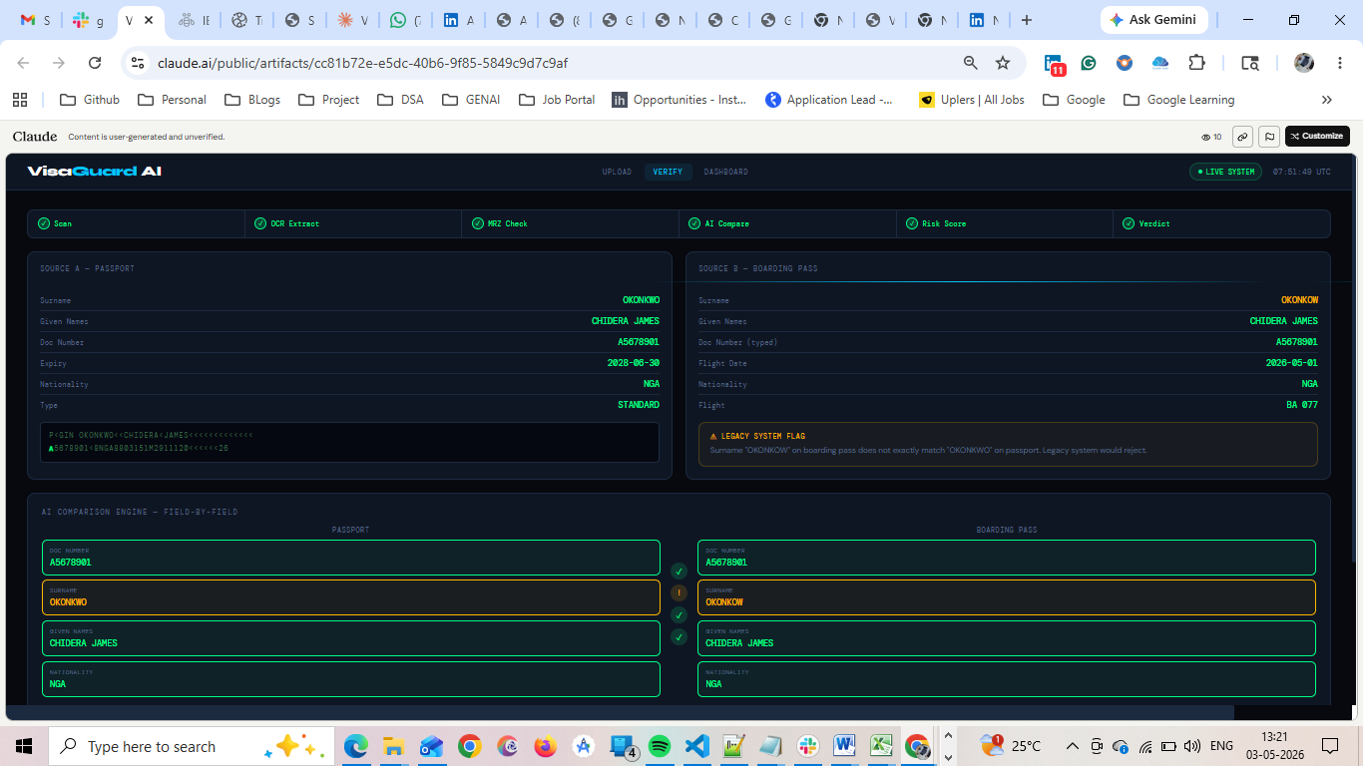
Dashboard:
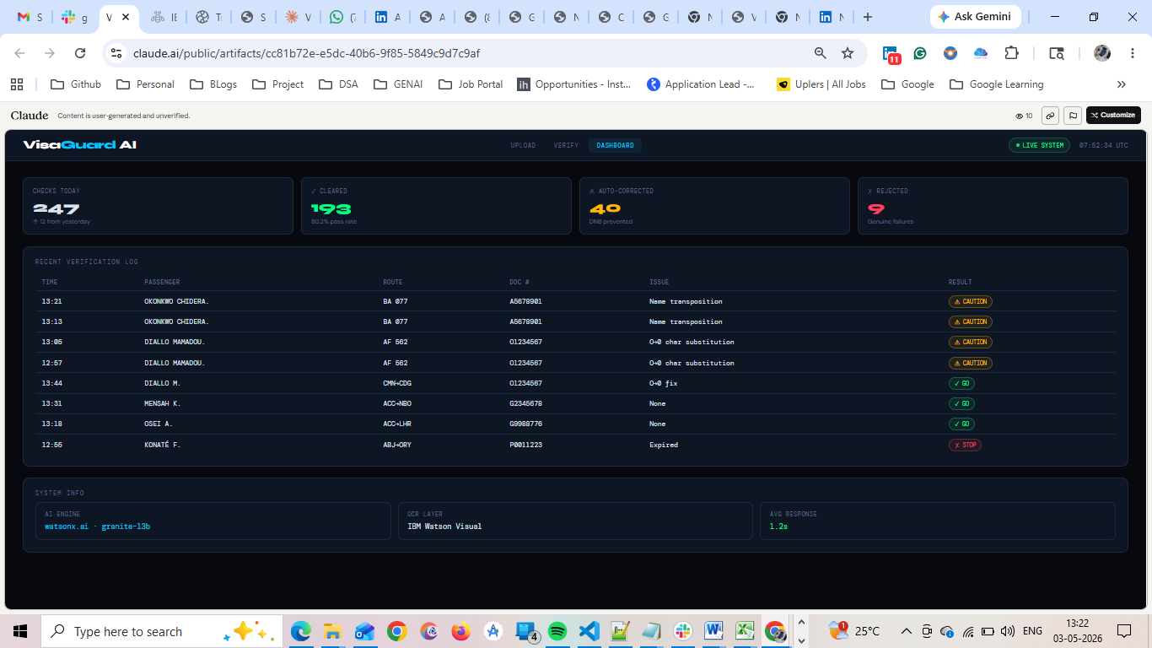

Expected Result:
⚠ LEGACY SYSTEM FLAG
Surname "OKONKOW" on boarding pass does not exactly match "OKONKWO" on passport. Legacy system would reject.

P5: Perfect Match (All Fields)
Input:
- All passenger and document fields match exactly
Legacy System Result: ✅ ACCEPT
VisaGuard AI Result: ✅ VERIFIED MATCH – Fully compliant
Confidence Score: 100% Decision: PASS
Upload:-
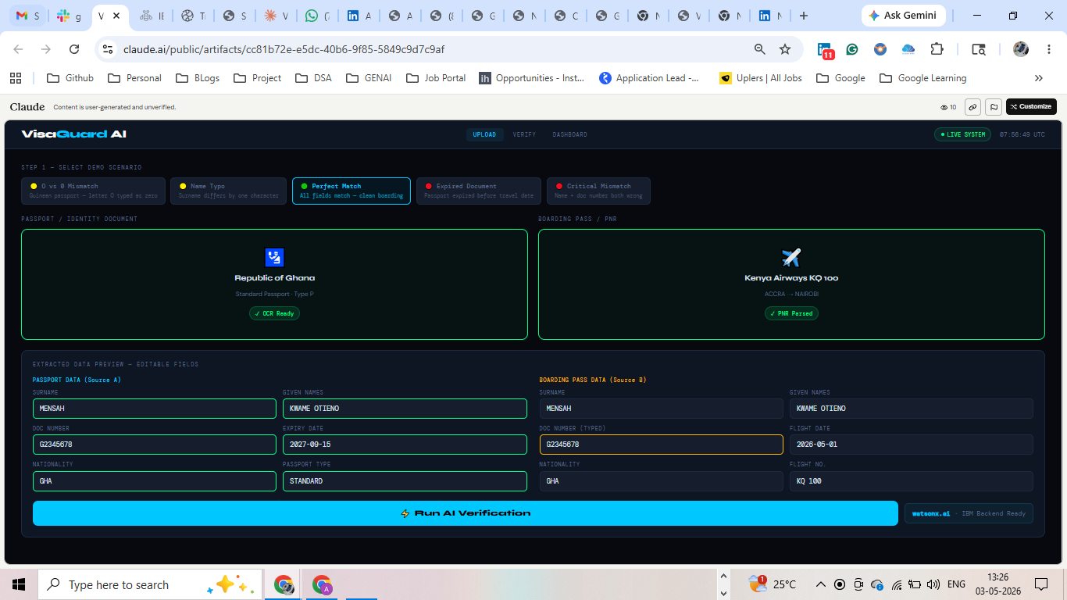

Verfiy:
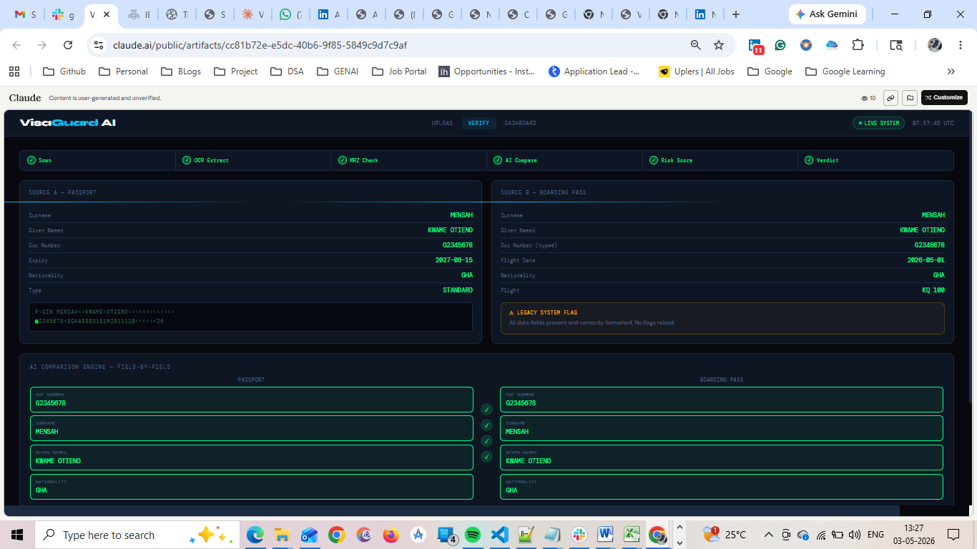

Dashboard:
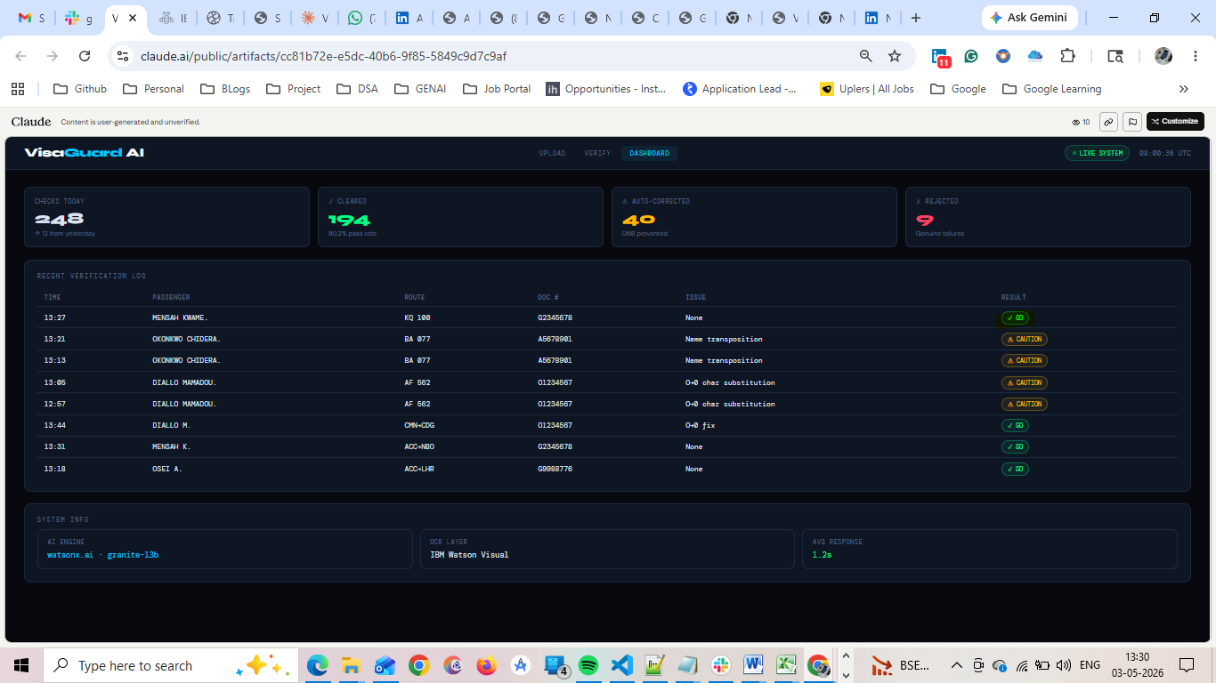

P6: Expired Document
Input:
- Expiry Date: 2025-03-01
- Travel Date: 2026-05-01
Legacy System Result: ❌ REJECT – Document expired
VisaGuard AI Result: ❌ REJECT – Expiry validation enforced
Confidence Score: 100% Decision: PASS
Upload:
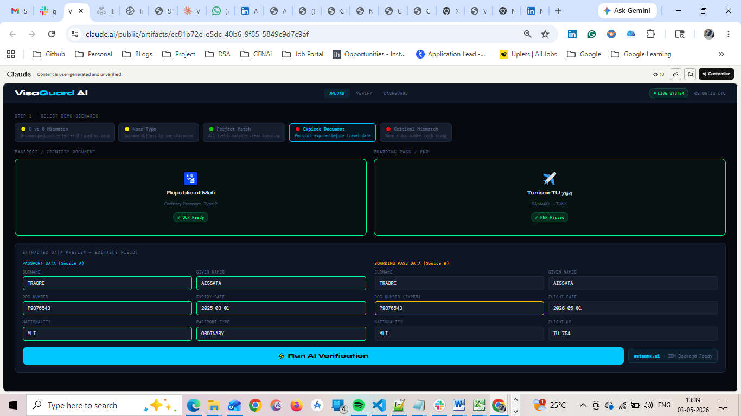
Verfiy:
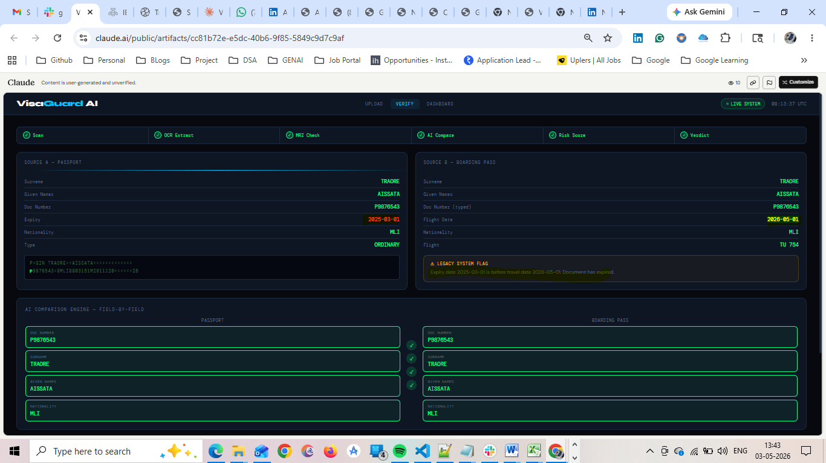
Dashboard:
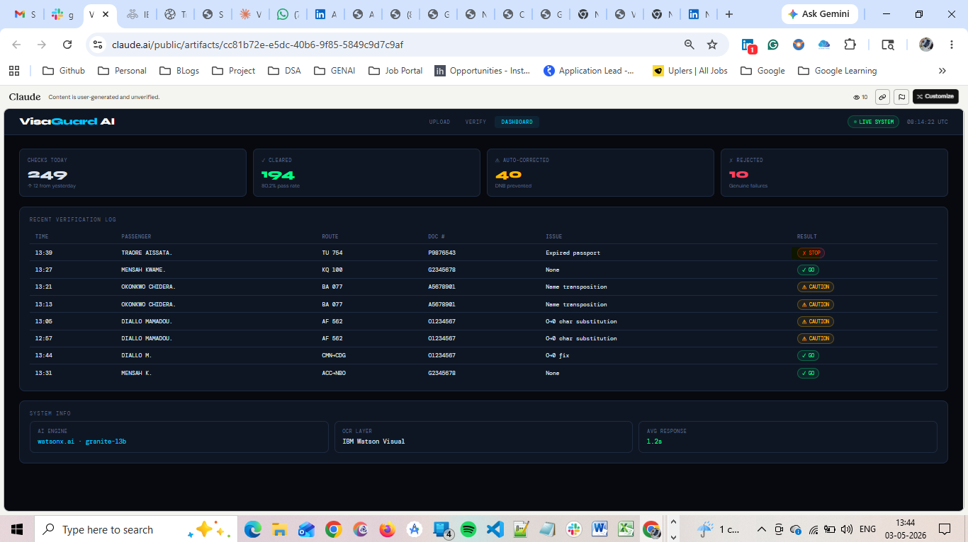

P7: Fraud / Critical Mismatch
Input:
- Passport: O1234567
- Ticket: Z9876543
Legacy System Result: ❌ REJECT
VisaGuard AI Result: ❌ REJECT – Multiple field mismatches detected
Confidence Score: 100% Decision: PASS
Upload: 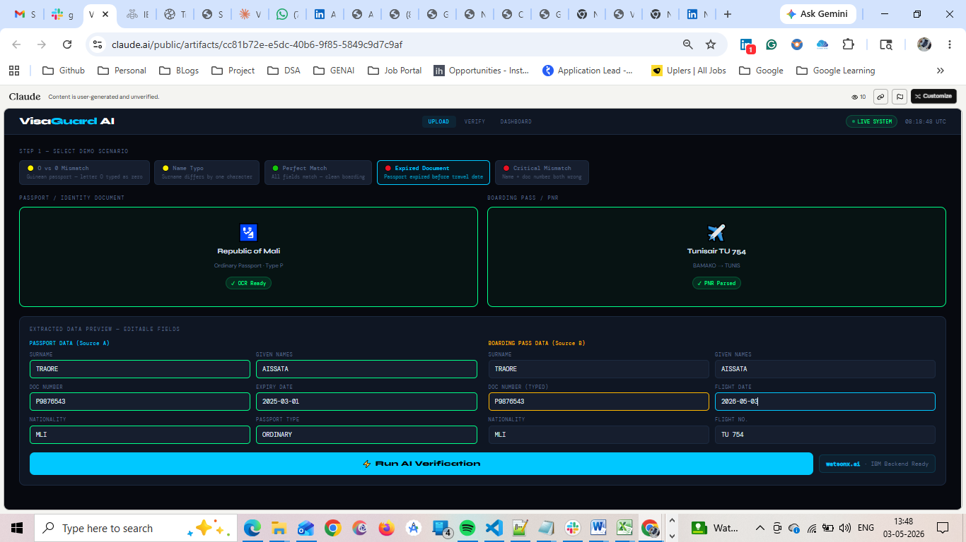
Verfiy:
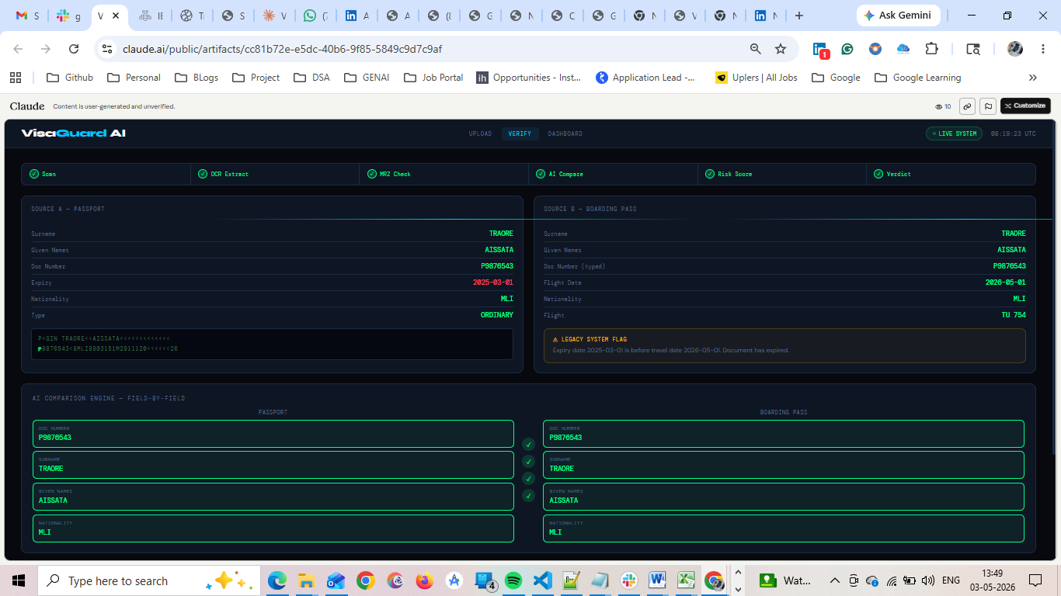
Dashboard: 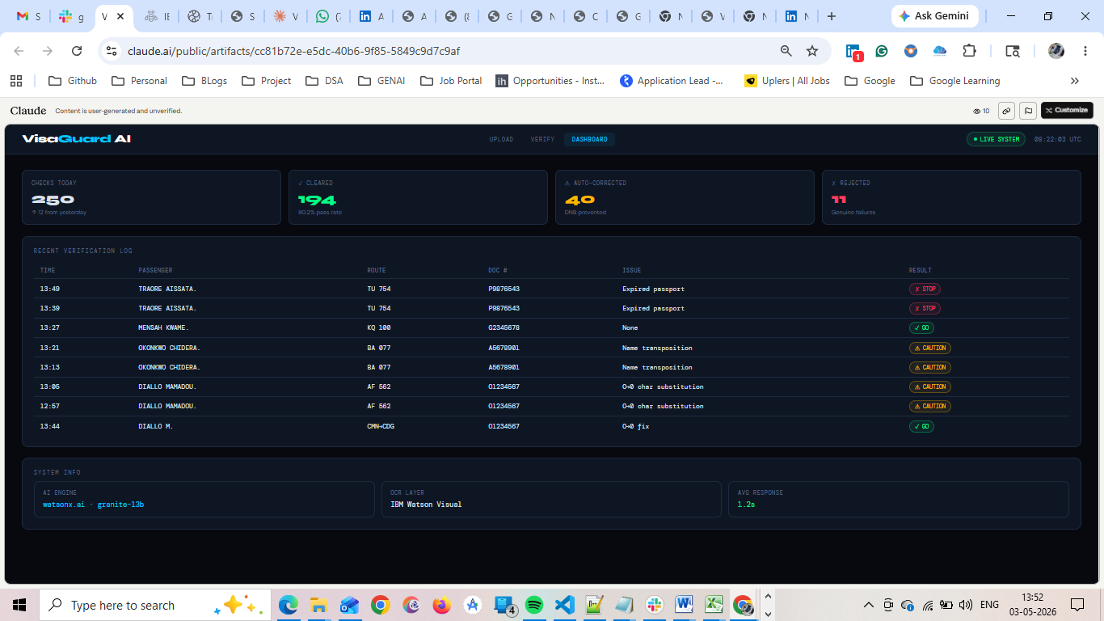

5. Scoring Model
VisaGuard AI uses a confidence-based decision framework:
- 90–100% → Auto Accept
- 80–89% → Accept with Advisory Flag
- <80% → Reject

Pass Criteria:
- Expected Result = Actual Result
- Confidence Score ≥ 80%
Each decision includes a one-line explainability output to support audit transparency.

6. Dashboard Metrics
The system dashboard provides real-time validation insights:
- Total Tests Executed:7
- Total Passed:7
- Total Failed:0
- Pass Rate (%):100
- Average Confidence Score : 97.57

Graphs:

These metrics ensure visibility into system performance and reliability.

7. IBM Compliance Mapping
Requirement | Implementation
Bob Session Logs | Execution tracking and traceability
AI Confidence | Confidence Score output
Validation Output | Pass/Fail decisions
Audit Trail | Decision reasoning logs
Evidence | Input comparison records
All outputs are exportable for audit and submission compliance.

8. Business Impact (ROI)

Current Industry Challenge
- Manual verification time: 3–5 minutes per passenger
- Average disruption cost: $50–$150 per case
- Escalation rate: 0.5% of passengers

Example: Mid-Size Airline
- Annual passengers: 20 million
- Mismatch cases: 100,000
- Cost per case: $50
Total Annual Cost: $5,000,000

With VisaGuard AI
- Automated validation: <2 seconds
- Reduction in manual intervention: 90%
Annual Savings: $4.5M+

Additional Benefits
- Reduced boarding delays
- Improved passenger satisfaction
- Increased operational efficiency
- Lower staffing overhead
VisaGuard AI transforms document mismatch handling from a manual exception into an automated decision layer.

9. Conclusion
VisaGuard AI delivers a scalable, high-impact solution to one of the most overlooked yet costly problems in airline operations. Through robust QA validation, contextual AI intelligence, and measurable financial impact, the system demonstrates readiness for real-world deployment.

10. Demo Validation Checklist
The final demo ensures compliance with submission requirements:
- Live O vs 0 mismatch detection
- Real-time AI confidence scoring
- Visual dashboard output
- AI vs Legacy comparison
- End-to-end workflow within 90 seconds

End of Report

